Entra Only Windows Device Re-imaging
- Device
  - Plugin power and network cable (dongle required)
  - Power On device
  - Leave device to boot up to Windows UI
- From Intune Portal
  - Go to Devices > Windows Devices
  - Search for device (can use Terminated username, serial number, computer name)
  - Open device Profile
    - On top ribbon for device, select Wipe.
    - Leave defaults and click Wipe (*please be certain you are wiping the correct device, you cannot undo once completed)
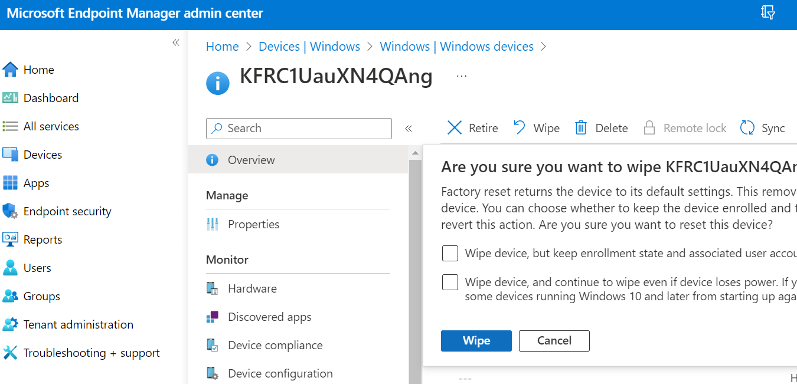
    - Click OK to confirm
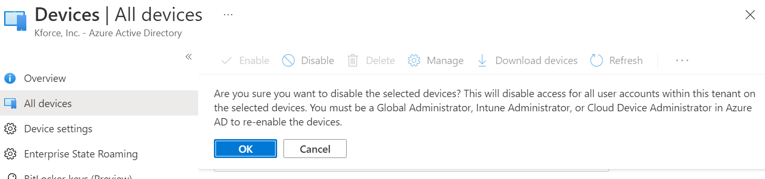
    - Device should reset in about 10 minutes.
- Device should at some point receive the wipe command and reset Windows back to OOBE. If the device doesn’t wipe, restart and wait 10 minutes. If it does not wipe again, follow the steps to Restore Windows Manually.
  - Once the device has completed wipe, you should see the Kforce branded OOBE screen
  - Open CMD prompt (shift + F10)
    - Shutdown device with below cmd, do not hold down power button
    - Shutdown /s /t 0
  - Device will be ready for redeployment after 24 hours
  - Place device on shelf.

